**Tutorial 9: Computed Property**

A computed property is a way to define a data property inside our components. This depends on other data that we have inside that component.

Make sure **Tutorial 8** is complete to be able to move on to this tutorial or clone the [vue3-firebase-course](https://github.com/younggrasshopperza/vue3-firebase-course) repository and go to branch called **Tutorial-8**.

In the **index.html** file, make sure the **body** tag has the below code:

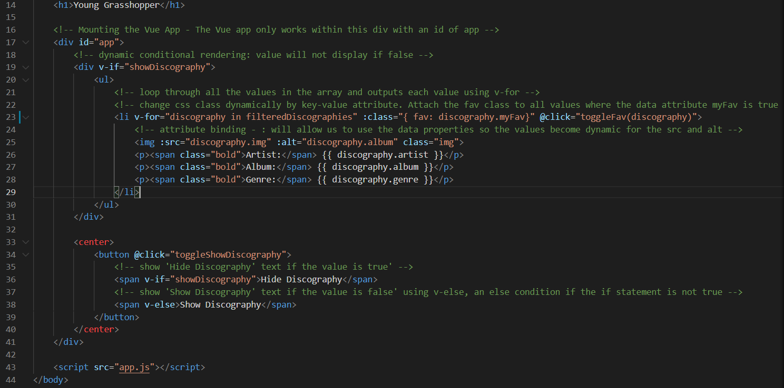

In the **app.js** file, make sure the code looks like the below:

**Step 1:** Continuing from Tutorial 8, in the **app.js** file, create a **computed** property inside the Vue App. Inside the computed property, create a function called **filteredDiscographies** which **filters** the **array of objects** to show all objects where the key **myFav** is set to **true**.

Look at the example below (**Line 40 to 44**):

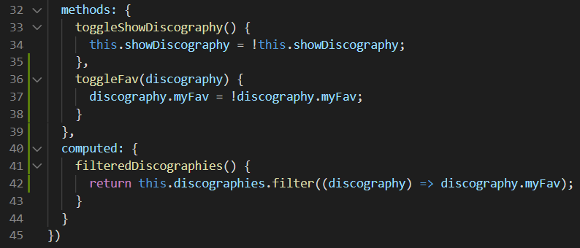

**Step 2:** In the **index.html** file, in the v-for, replace the value discographies with filterDiscographies. Only values where myFav is true will be displayed.

Look at the example below (**Line 23**):

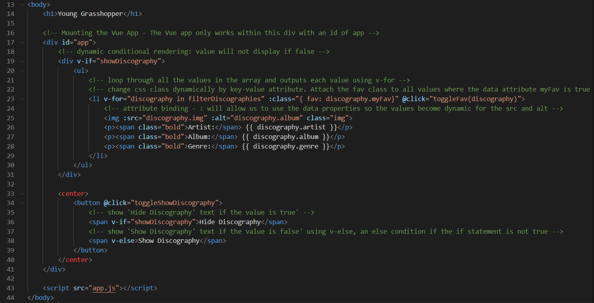

**Output:**

If you click on the discographies on the screen, myFav will change to false and the discography will disappear.

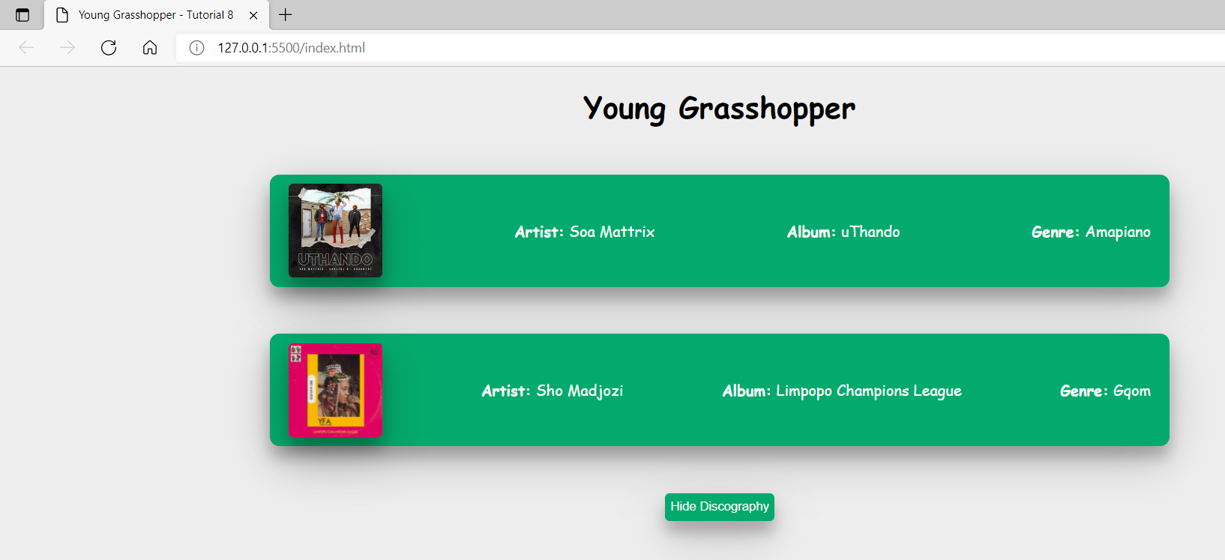

**You can view the code snippets from the** [**vue3-firebase-course**](https://github.com/younggrasshopperza/vue3-firebase-course) **repository under the Tutorial-9 branch.**